Department of History,
Amar Singh College, Srinagar

Report on Student Induction Programme 2026

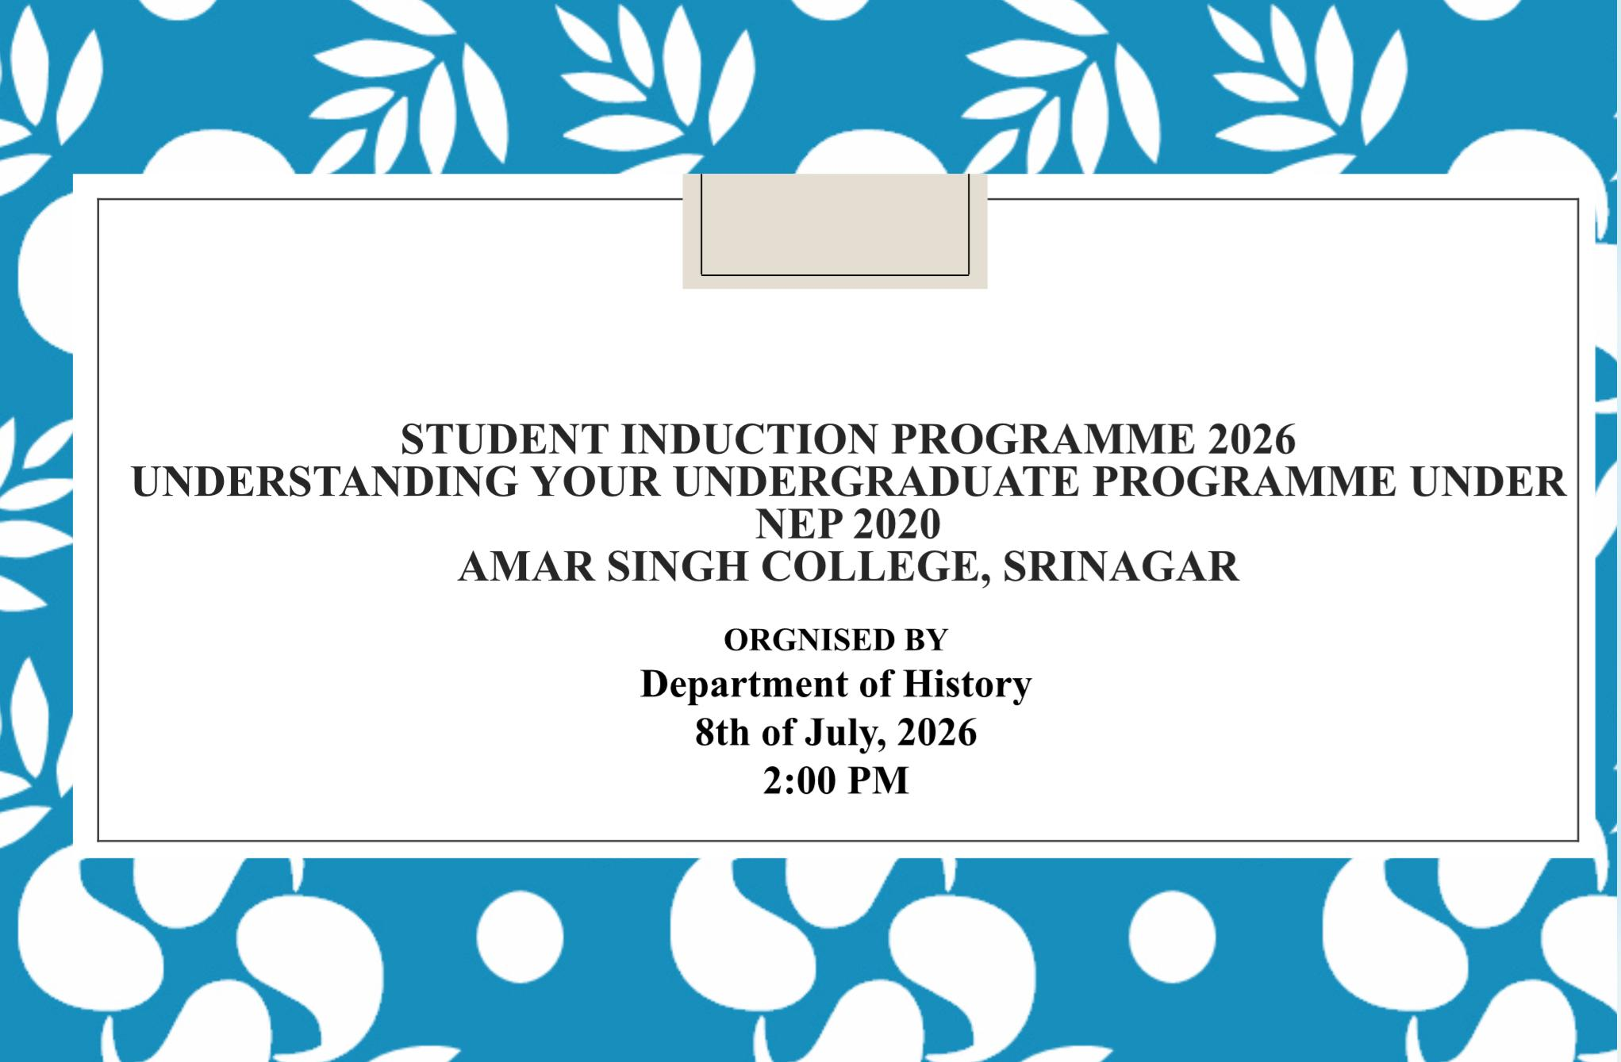
The Department of History organised a Student Induction Programme for newly admitted first semester students to familiarise them with the Undergraduate Programme under NEP 2020. The session was conducted by Prof. Masrat John, Head, Department of History, who welcomed the students and introduced them to the academic environment, departmental activities, and opportunities available through the History programme.
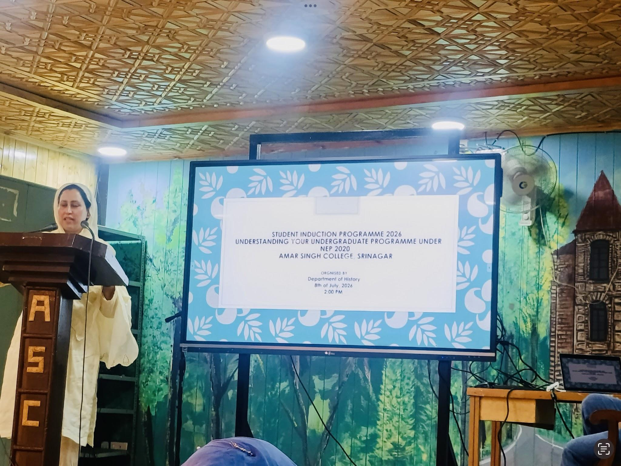
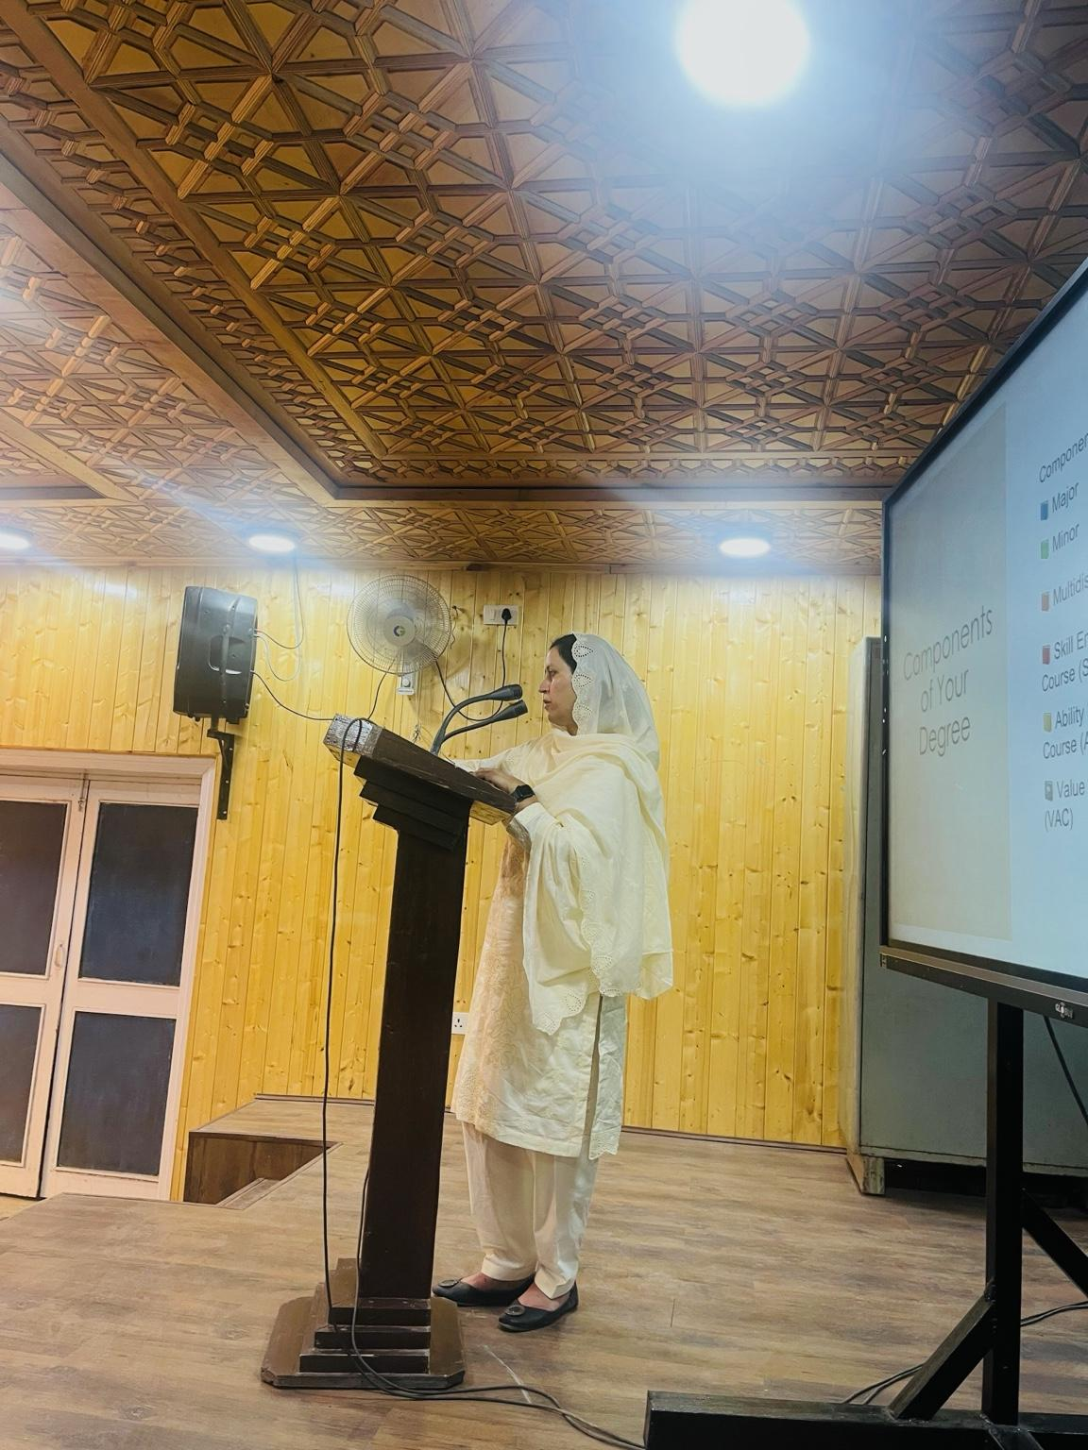
A detailed presentation explained the structure of the four-year undergraduate programme, including Major, Minor, MDC, SEC, AEC and VAC courses, the Academic Bank of Credits (ABC), continuous assessment, internships, and career opportunities. Students were encouraged to actively participate in seminars, heritage walks, educational tours, research activities, and extension programmes.
The programme concluded with an interactive question-and-answer session where students' queries regarding course combinations, examinations, and career prospects were addressed. The induction programme successfully acquainted students with the academic framework of the college and inspired them to begin their higher education journey with confidence and enthusiasm.

